Large Archive Folders can be slow to access in Outlook and, if they get too large, can become corrupted resulting in lost information. For both performance and reliability, it is better to have multiple smaller archive folders.
You can split your Archive Folder into two pst files in three steps:
- Create a new .pst file to move the messages into
- Move the messages from the Archive Folder to the new .pst file
- Compact the Archive Folder
The example below shows how to use the year/date criteria to split your Archive Folder into two folders by moving all messages dated before January 1, 2009 into a new file called Archive2008.pst.
In Outlook, Click File->Data File Management
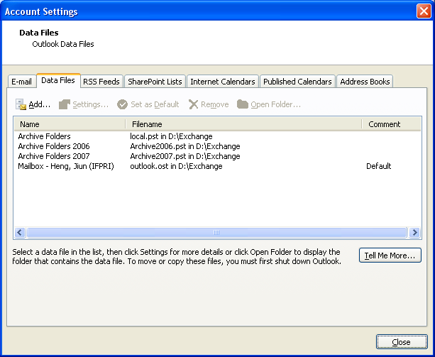
Click Add under the Data Files
Select Office Outlook Personal Folder Files (.pst) and click OK
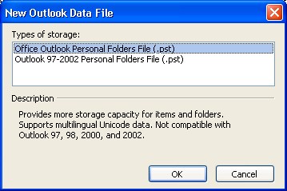
Browse to D:\Exchange\ and give the new pst file a name, for example Archive2008 and click OK.
Give it a name (for example, Archive Folders 2008) to make it easier to identify in Outlook.
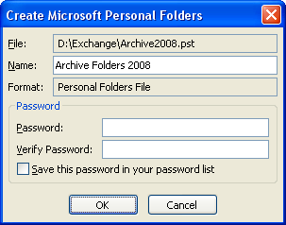
Click OK and Close.
You are back to Outlook and have created an empty .pst file to move your old messages into.
What we are doing next is to move the email older than 1/1/2009 in your Archive folder (local.pst) to Archive2008.pst.
Click File->Archive
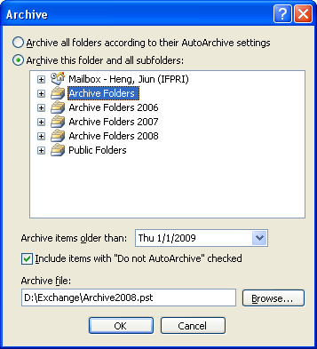
Select Archive this folder and all subfolders.
Highlight the folder you want to split.
Put in a date for Archive items older than. In this case, I put in 1/1/2009.
Check include items with “Do not AutoArchive” checked.
Under Archive file, browse to D:\Exchange\Archive2008.pst.
Click OK.
You can see the progress in the lower right of Outlook.
Though you have removed many messages from your Archive folder, it will not give back the space automatically. Once it is done. You need to right click on your Archive Folder, select Properties, click on Advanced, and click Compact Now.
