Instructions: Using Tools for Organizing Events
Prepared by Valerie Rhoe
May 19, 2011

Brief descriptions of each database and template along with the files are available on the IFPRI intranet at IFPRI Info/ Communications/ Policy Seminar and Conference. It is suggested that you open each word template and excel workbook to become familiar with the information that is included and its structure. The word templates are in unlocked word form mode so changes can be made to all text.
Figure 1
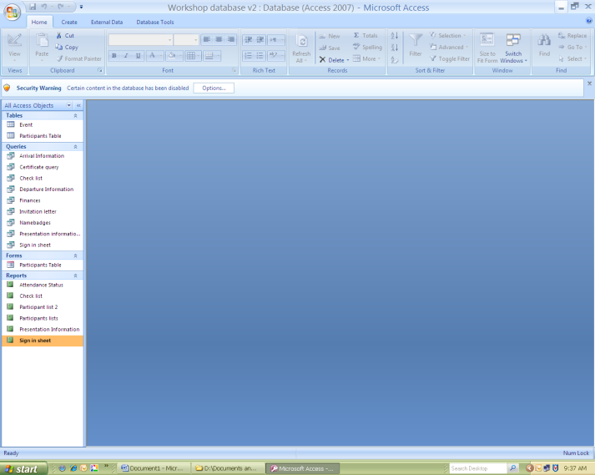
Step 1: Save all files onto your computer or share drive.

Step 2: Open the Microsoft Access Workshop database v2.accdb by double clicking on the file. The Database will open as shown in Figure 1. This Access database has 4 types of files that we use: forms, tables, queries, and reports

Step 3: Input data on the event. The access database table is similar to an excel table for entering data. You double click on “event” under tables (Figure 2). Given that each event has only a few variables, a form was not created for inputting information into this table, therefore, data will be inputted directly into this table.

The Event ID is automatically calculated by Access and cannot be changed.
To open event table
Figure 2

Save changes.

Once information about the event is inputted in the “event” table, it is time to begin inputting information about each participant. Information can be manually added or you can import information from external data sources such as Outlook, Excel, SharePoint, etc (Figure 3). We will be manually inputting the data in this set of instructions.

Figure 3

Step 4: Under forms, select “participant table” (Figure 4). This is a form for inputting information into the table regarding participants. You can input data directly in the table as well, if you like the data entry format more.
Once you double click on form, the information for the 1st entry (participant) will appear. You can add, delete, and change information for this participant

Figure 4
Form for the participant database
This informs you of the number of entries
You can view each participant information by clicking on these arrows to move through the data.

Step 5: Entering data for a new participant
An attempt has been made to include the data that is typically required about each participant for organizing an event, but it’s not necessary to fill in all the data entry spaces if it is not relevant to your event. There are 2 exceptions (Figure 5):
- PersonID: This is an automatic number generated by access; each new entry will be assigned a unique identification code.
- EventID: This database was set-up for multiple events with the same participants; to ensure that the queries and reports produce accurate information, you need to identify which event the person is being invited to attend from the “Event” Table.

After entering the information, you will need to “save” the information before it will appear in the table, queries, or reports.

Please note if the information is not in this form, it will not appear in the table, queries, or reports. Also, if the information is not correct or misspelled, it will appear exactly as it is in this form. The nice thing about this database is once you confirm all information is spelled correctly, you do not need to verify if the information is spelled correctly on all documents that pull from this database.
EventID
PersonID
Figure 5
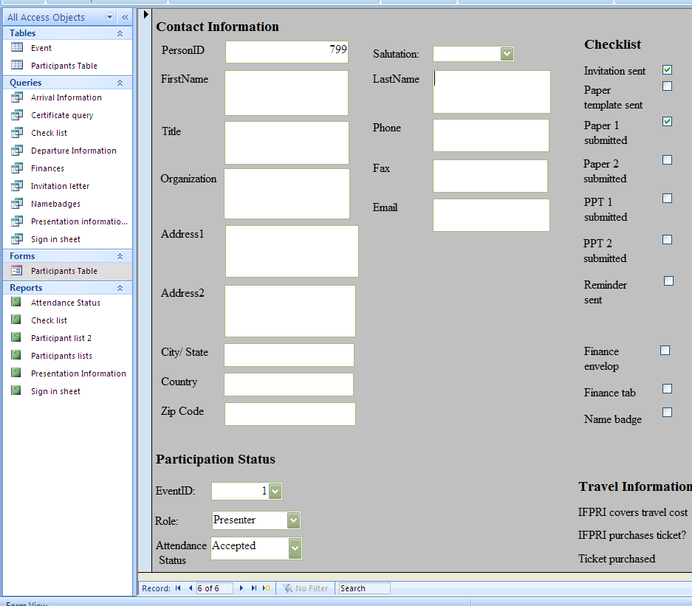

Step 6: View data in the Participant Table (Figure 6). Make sure the information in have entered in the form appears in the table. If it does not appear, go back to the form and select save.

Figure 6
Double click on participant table

Step 7: Pulling information for queries and reports. A series of queries and reports that are commonly needed or wanted have been prepared in this access database. The queries developed for this database are listed under the query title in the database. A description of each of these queries is provided in the attached document titled “brief description of databases and templates.”

To view any query or report you double click on the query/ report you would like to view. A viewed query can be exported and printed. However, sometime a query is develop not as an end in itself but as a means for other products. Several queries in this database were develop to ease mail merging with word and excel files or for creating a report more easily. These queries include:

- Certificate
- Check list
- Finances
- Invitation letter
- Name badges
- Sign-in Sheet

Step 8: As mentioned in the previous step, some queries were designed to allow for information from access database to be mail merged or imported into word documents or excel workbooks. Currently, information can be fed into the following templates (unlocked)
- Invitation letter
- Name badges
- Allowance/ Reimbursement excel workbook
- Allowance/ Reimbursement form

To mail merge any document, the spreadsheet in which the data will be imported from must be closed.

Since the templates have been set-up for a mail merge already, the process to mail merge is only a few steps. After opening the template, select the heading “Mailing,” then click on “Select Recipients.” Select “using Existing List” (Figure 7).

Figure 7

Step 9: Locate the Access Participant database and select the appropriate query (namebadges or invitation letter) (Figure 8) and click “ok.” This will import the proper information into the word template.

Figure 8
After selecting the appropriate query, you can “preview results.” After previewing the results, you can select “Finish and Merge.” I recommend “Edit Individual documents”. This will produce a word document that you can review, test print, and save.

Figure 9

Instructions on how to mail merge into the name badge template from the beginning without using this database is available on the IFPRI Intranet. Similar instruction can be followed for mail merging a letter.

Step 10: Preparation of Allowance/ Reimbursement Documentation.

Step 10A: Ensure the access database is closed; open the appropriate excel workbook (there are 2 excel workbooks: 1) participants from many countries and 2) participants from 1 country being reimbursed in local currency). Now it’s time to import the participant data from the Microsoft Access Participant Database into the allowance/ reimbursement excel workbook. When you open the excel workbook, you will notice that information is missing in the first 9 columns. This information will be imported from the Access Participant Database. To import data, open the “Data” heading and select the “From Access” Tab. Then open the access file.

Figure 10

Step 10B: Then select the “Finances” query.

Figure 11

Step 10C: Place your cursor in Column A Row 1 and select “OK”

Figure 12

The information from the “Finances” query is automatically inputted into the 1st 9 columns of the excel worksheet. The only names that will appear in this excel sheet are those in which IFPRI has agreed to cover their travel costs. If there are participants in which IFPRI will not reimburse them for their travel cost they will excluded from this merge.
Figure 13

Step 10D: Now you need to manually insert the information for the remaining columns in which there are expenses (air ticket, transit hotel, per diem/ incidentals, honorariums, etc) The excel sheet has formulas to calculate the US $ equivalent when necessary and to add the appropriates columns as needed. When the information is final, it can be mail merged into the Allowance/ Reimbursement form.

To mail merge the Excel Database must be closed.

Step 10E: Open the Workshop Reimbursement Form. You will need to manually type the information in that is highlighted in yellow. Then select “using existing list” from the “select recipients” tab.

Step 10F: You will open the Allowance/ Reimbursement Excel Workbook and select the “Reimbursement” worksheet. After opening the data source, select “preview results” then “Finish and Merge”

